*\*MAJOR CONCERT ANNOUNCEMENT\*\**

***BURNING MAN TOUR 2019***

**DIERKS BENTLEY**

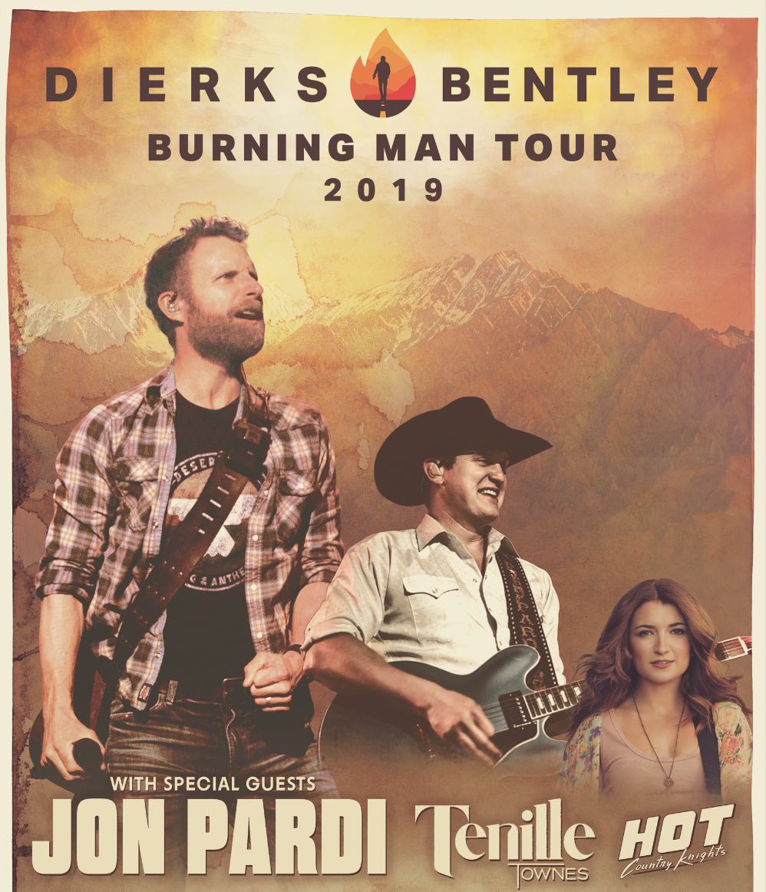

**WITH SPECIAL GUEST**

**JON PARDI**

**TENILLE TOWNES**

**HOT COUNTRY KNIGHTS**

**SATURDAY, MARCH 2nd**

**CHI HEALTH CENTER**

**OMAHA, NE**

|  |
| --- |
| **TICKETS ON SALE FRIDAY, NOVEMBER 9TH AT 10AM!**  [www.LiveNation.com](http://www.LiveNation.com)  Venue Box Office | 800-745-3000 |